**JavaScript Console**

1. Go to **Google Chrome > Ctrl + Shift + I (Windows)** and **Cmd _Opt + I (Mac)** to select Developer tools from Chrome menu to open **JavaScript Console**

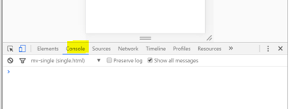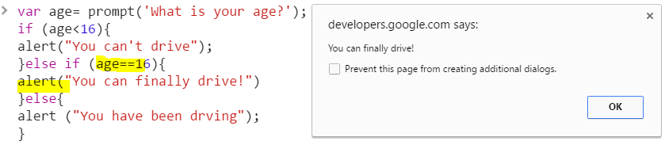

1. **Writing JavaScripts using Eclipse IDE:  
   R-click Src > New > Other… > Web > HTML File >** click **Next >** type **File name > Finish**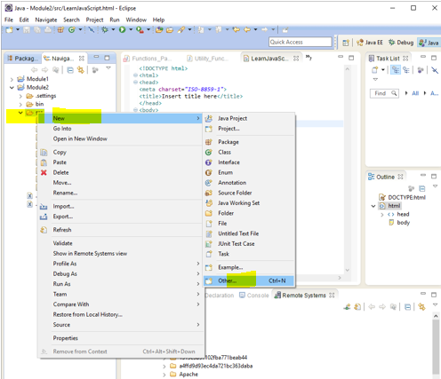

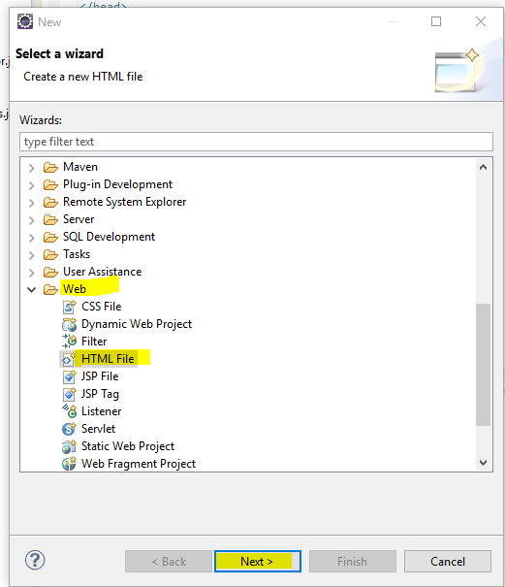

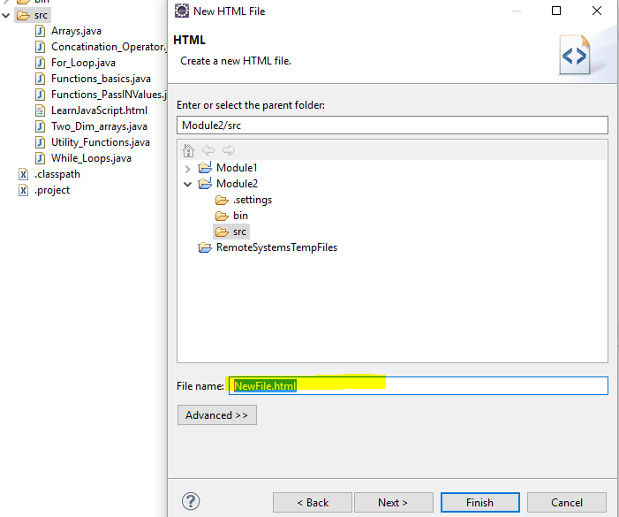

1. **R-click HTML File > Show in Remote Systems view** to see the **Dir** path

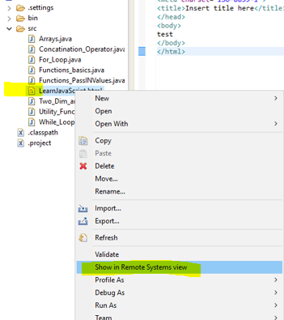

1. In File Explorer: C:\Work\Java\Module2\src. Then, double click the (**LearnJavaScript.html**) File or drag and drop the file in any Browser to browse the page.  
   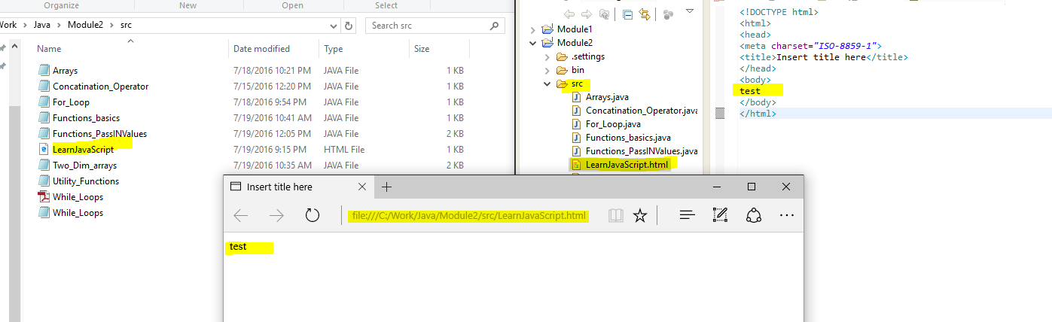

<file:///C:/Work/Java/Module2/src/LearnJavaScript.html>